**Name : Ali Azhar**

**Roll Number : SU92-BSAIM-S24-026**

**Section : 2A**

**“Object Oriented Programming”**

**Lab 02 – Task**

**Task 1 :**

**“Class Concepts”**

1. **CLASS :**

* A class is like an object constructor, or a "blueprint" for creating objects.
* It define the properties(attributes) and behaviors(methods) that the objects created from the class will have.
* A class is created by a keyword “class”.

E.g:

class Mytask:

pass

1. **Objects :**

* Memory is allocated when an object is created. Each object holds specific values for the attributes defined in the class.
* An instance of class. It is a specific, concrete entity created using the class blueprint, with it’s own values for the attributes defined by the class.
* An object is created by the follwing method:

E.g:

a = Mytask()

print(a)

**Example:**

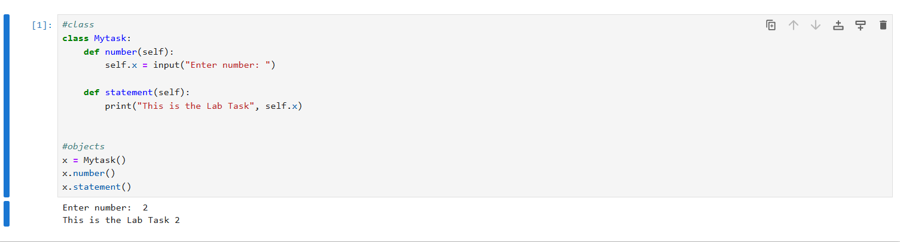

1. **__init__ :**

* All classes have a function called __init__(), which is always executed when the class is being initiated.
* Use the __init__() function to assign values to object properties, or other operations that are necessary to do when the object is being created.
* It is the built-in function also known as constructor.

E.g :

def __init__(self):

1. **__str__ :**
   * Called when the object is passed to print() or str().
   * Returns a human-readable string representation of the object, used when you print the object or convert it to a string.

E.g :

def __str__(self):

**Example :**

